RESEARCH REPORT

Internet of Things (IoT) Application in Healthcare Monitoring

Submitted by : Tanu Gajanan Kalambe

Submitted to : CodeAlpha

Academic Year : 2025-26

Introduction
The Internet of Things (IoT) is a technological framework that enables physical devices to communicate and exchange data through the internet. These devices include sensors, wearable gadgets, medical equipment, and smart systems capable of collecting and transmitting real-time information. IoT has revolutionized multiple sectors such as healthcare, agriculture, smart homes, transportation, and industrial automation. In healthcare, IoT provides continuous monitoring of patients, remote healthcare services, and improved decision-making through data-driven insights. By connecting medical devices, healthcare professionals can monitor patient conditions from any location, reducing costs and improving the quality of care. This report examines the real-life application of IoT in healthcare monitoring, its benefits, challenges, and future prospects.

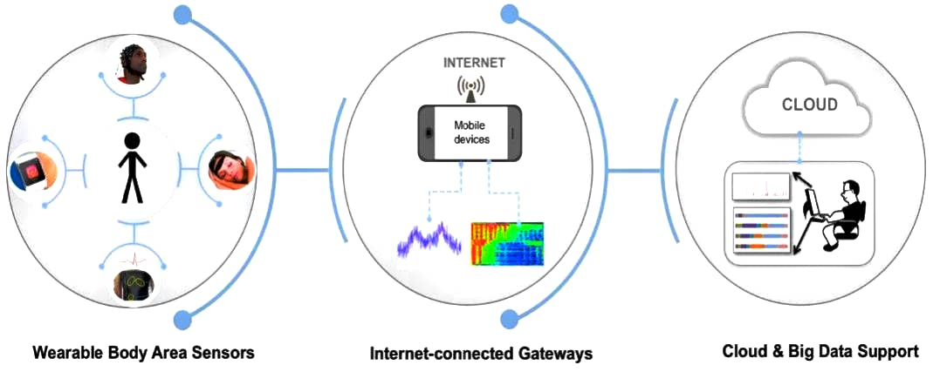

- Figure no:1

IOT -Based Healthcare Monitoring System
Architecture showing how patient data is collected through sensors and transmitted to healthcare providers.

IoT Application in Healthcare Monitoring
Healthcare monitoring through IoT involves smart devices that continuously collect patient data such as heart rate, blood pressure, oxygen levels, body temperature, glucose levels, and physical activity. These devices communicate with cloud platforms and healthcare systems where the data is analyzed and made available to doctors and caregivers.
IoT technology has significantly improved the healthcare sector by enabling real-time monitoring and remote patient care. Wearable devices such as smartwatches, fitness bands, and smart sensors collect vital health information and transmit it through wireless networks. Healthcare professionals can access this information from anywhere, allowing faster diagnosis and treatment.
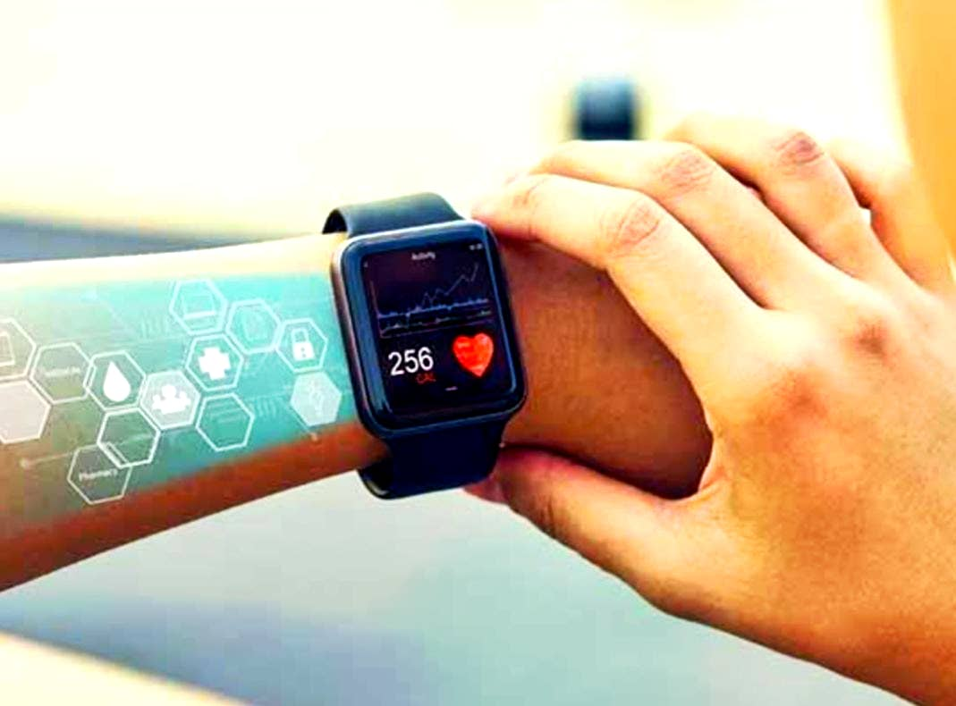
- Figure no:2
Wearable Health Monitoring Devices
Smart devices used to collect patient health data in real time .

Real-Life Applications
Remote Patient Monitoring (RPM) allows doctors to monitor chronic disease patients without requiring frequent hospital visits. Wearable devices help manage conditions such as diabetes, hypertension, and cardiovascular diseases. IoT is also widely used in elderly care. Smart wearables and fall-detection systems can immediately alert caregivers during emergencies. Hospitals use connected medical equipment and smart beds to track patient conditions and improve response times
.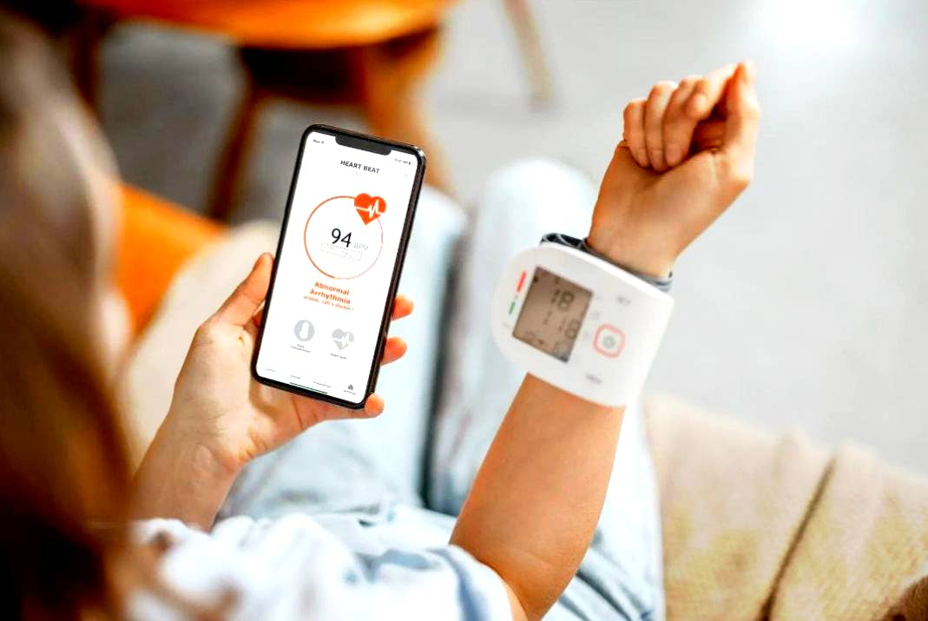
- Figure no: 3

Remote Patient Monitoring Using IOT
Healthcare professionals monitoring patient health remotely through connected devices and cloud platforms .

Benefits
- Continuous health monitoring and early detection of diseases.
- Reduced hospital visits and healthcare costs.
- Improved efficiency through automated data collection.
- Better patient engagement and preventive healthcare.
- Support for personalized treatment plans.

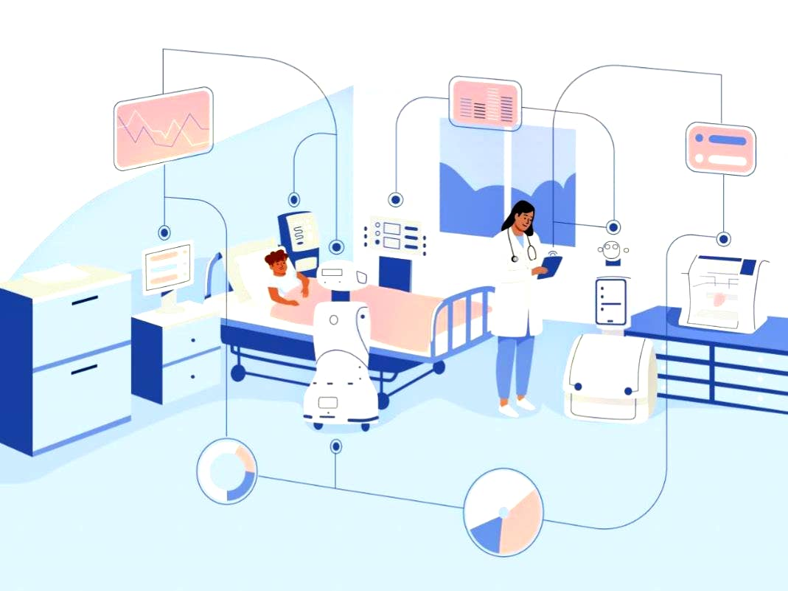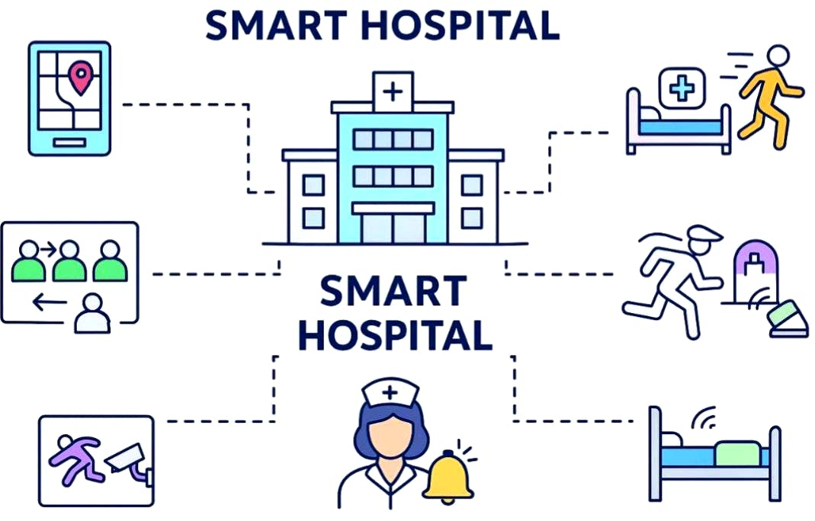
- Figure no:4
Smart Hospital with IOT Technology
Connected medical devices improve efficiency and patient care.

Challenges
Data privacy and cybersecurity risks remain major concerns. Device reliability, interoperability, and implementation costs can also affect widespread adoption. Healthcare organizations must ensure secure systems and proper integration of IoT devices.

Future Scope
Future healthcare systems will combine IoT with Artificial Intelligence (AI), Machine Learning, cloud computing, and 5G networks. These technologies will enable predictive healthcare, faster diagnosis, and improved access to medical services, especially in rural areas.
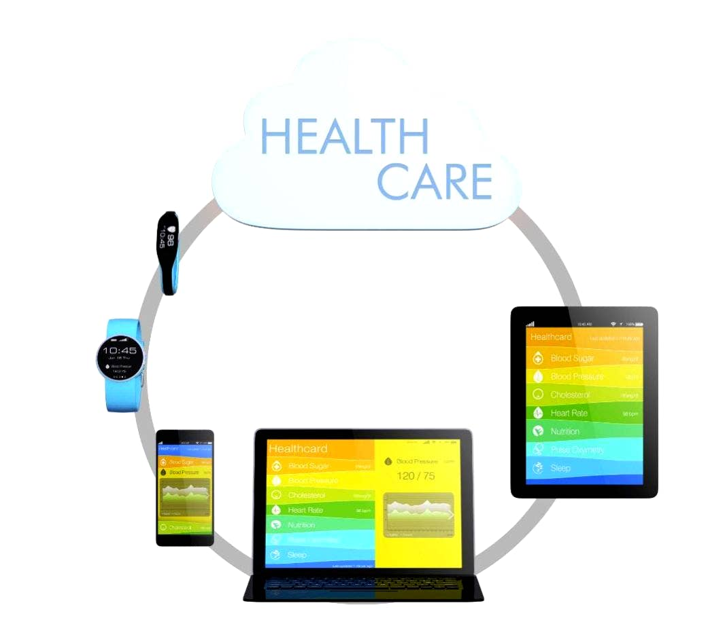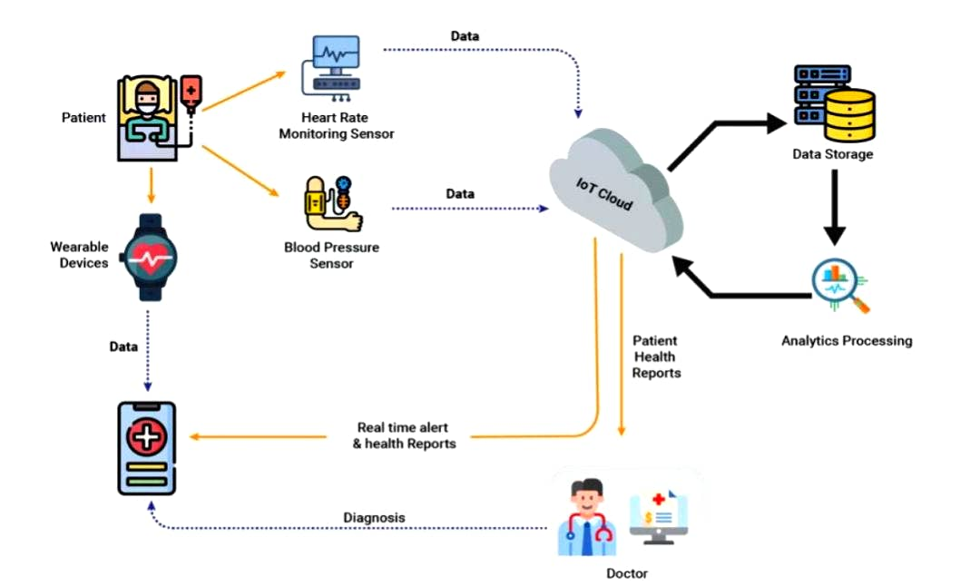
- Figure no:5
Cloud-Based Healthcare Data Management
Cloude Platforms store and analyze patient data for decision-making

Conclusion
IoT has transformed healthcare monitoring by enabling real-time patient observation, remote care, and efficient healthcare management. Although challenges exist, technological advancements continue to improve reliability and security. IoT is expected to play a central role in the future of healthcare by providing smarter, more accessible, and personalized medical services.

References
- World Health Organization (WHO). Digital Health and Connected Care Resources.
- IEEE Internet of Things Journal – Healthcare IoT Research Publications.
- Gubbi, J., Buyya, R., Marusic, S., & Palaniswami, M. (2013). Internet of Things (IoT): A Vision, Architectural Elements, and Future Directions. Future Generation Computer Systems.
- Kumar, P., Lee, H. J., & Lee, H. (2020). E-Healthcare Monitoring Systems Using IoT. Sensors Journal.
- Islam, S. M. R., Kwak, D., Kabir, M. H., Hossain, M., & Kwak, K. (2015). The Internet of Things for Health Care: A Comprehensive Survey.
- Patel, S., Park, H., Bonato, P., Chan, L., & Rodgers, M. (2012). A Review of Wearable Sensors and Sys
- tems with Application in Rehabilitation.

